**TC013 – Excessively long string in additionalneeds**

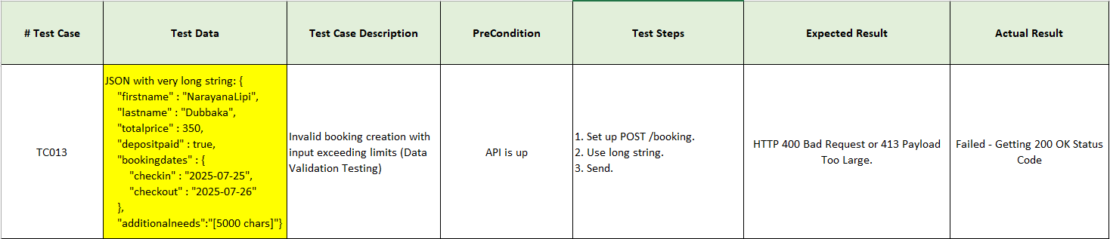

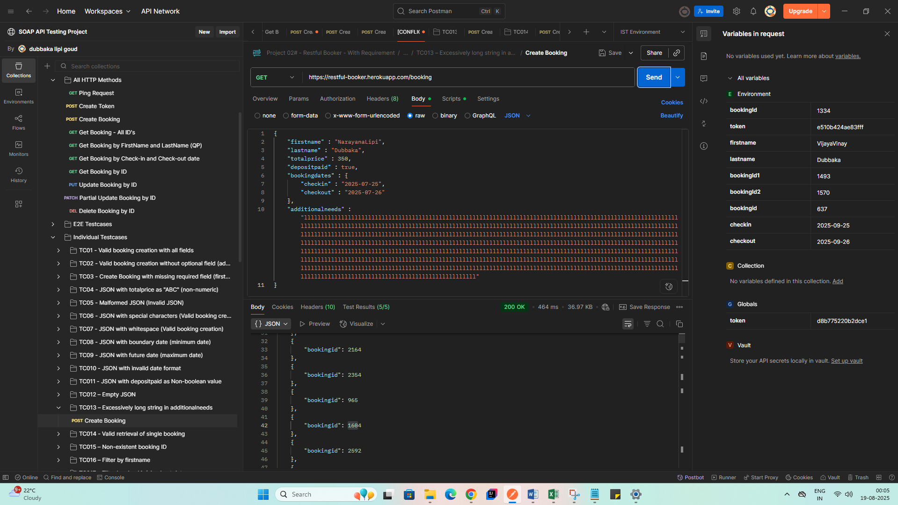

* Getting lots of Booking ID’s instead of 1 Booking ID with its details.

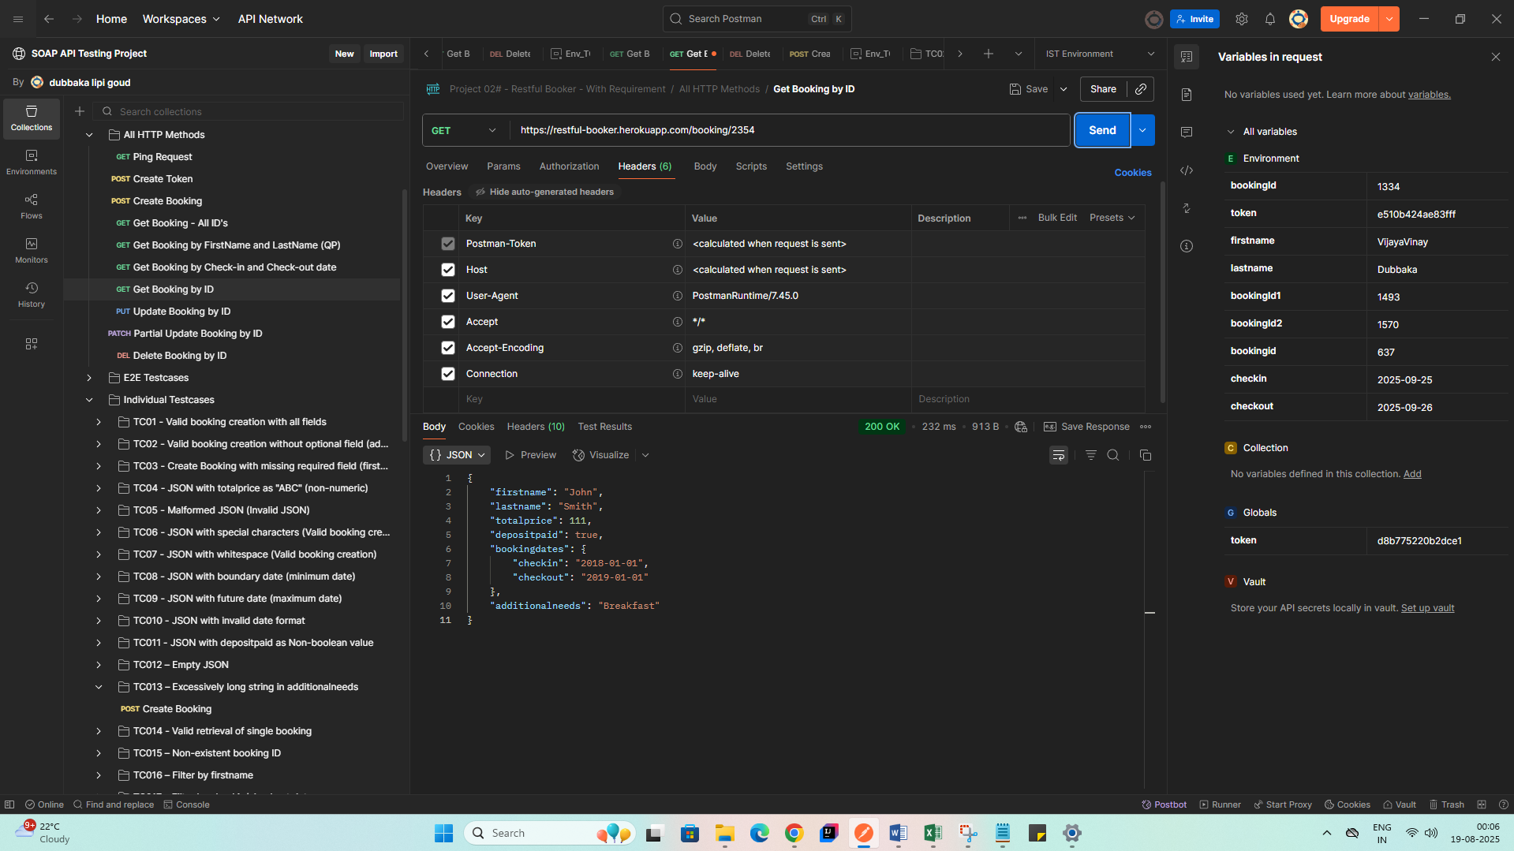

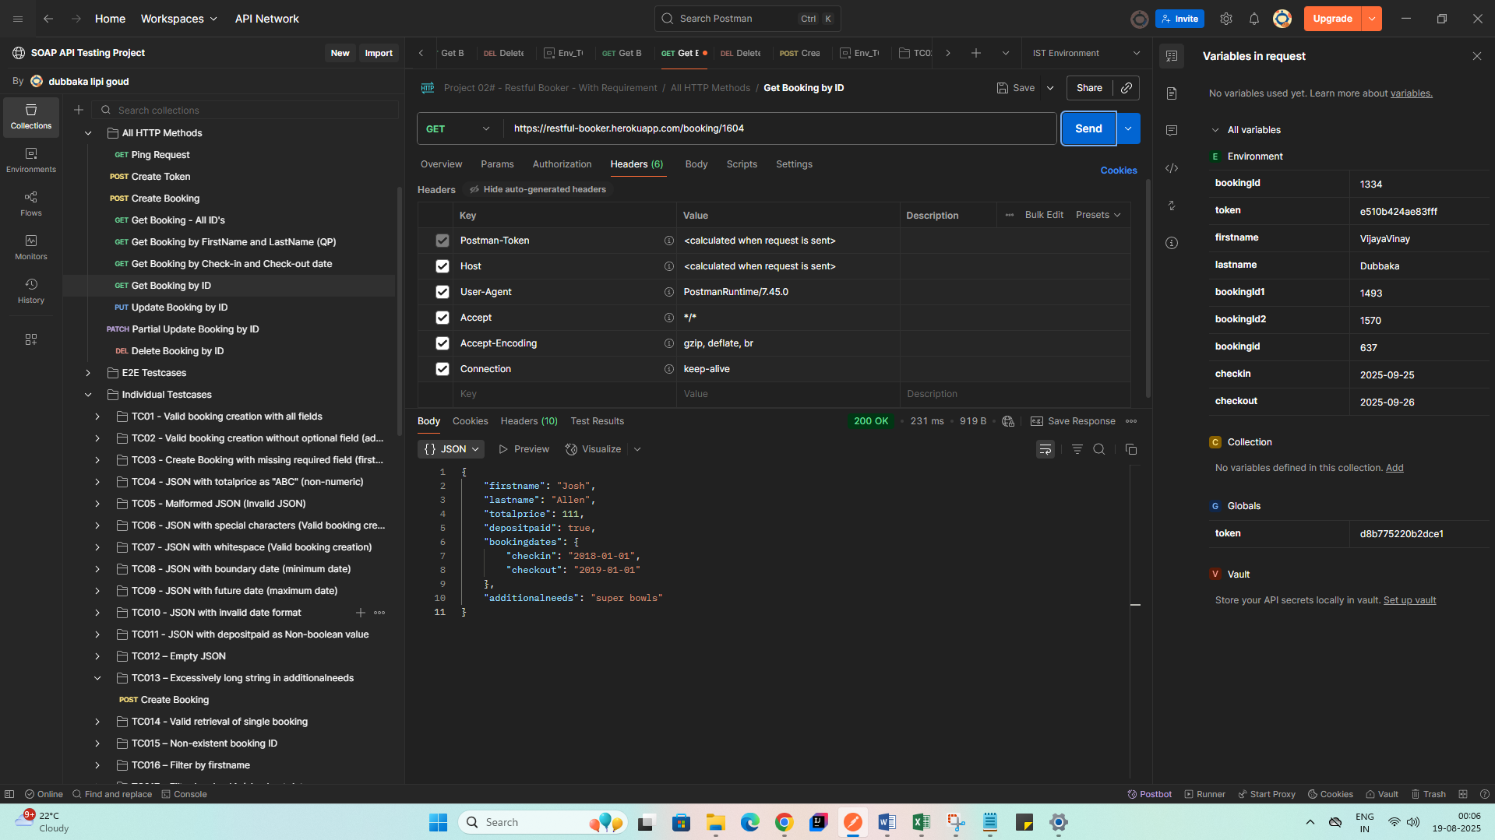

* Searched with the generated Booking ID’s but getting unrelated Booking data in Response.

**Bug:** API accepts excessively long string in additionalneeds field and returns unrelated booking data

Steps to Reproduce:

1. Set the additionalneeds field to an excessively long string (e.g., 1000+ characters).
2. Send the request.
3. Observe the response status and returned bookingid’s.
4. Perform a GET request to retrieve booking details using the returned ID.

### **Actual Result:**

* API responds with 200 OK and returns a valid bookingid.
* When the booking is fetched using the returned ID, it shows **unrelated** or **previously existing** booking data.
* The long string in additionalneeds is **not** saved.
* Data mismatch observed between request and actual stored booking.

### **Expected Result:**

The API should:

* Either reject the request with 400 Bad Request due to input validation.
* Or correctly save and return the submitted data, including the long additionalneeds field.